ECE496 Proposal

Magnetic Field Simulator Web Application

Supervisor: Belinda Wang

Administrator: Stewart Aitchison

Team Members: Mehdi Essoussi, Son Phatpanichot, Achu Mukundan, Justin Chang

Date of Submission: October 25 2024

# Executive Summary

We live in an era where vibrant visuals shape entertainment, advertising, and communication, yet engineering education tools lag behind, relying on static images and basic software. Our project addresses this gap by creating a tool that intuitively visualizes core concepts for electric and magnetic fields. This tool will be available as a website so students can access it from any device, wherever they find it convenient to study. In terms of requirements, we are constraining ourselves to a two dimensional application. This eases development on our end as well as simplifies the interface for the user. We will focus on making the tool highly interactive, allowing students to experiment by easily adding or removing charges and fields, and adjusting their parameters to observe the resulting effects; a hands-on experience. This will allow students to simulate more practical and complex interactions. We have devised a project timeline consisting of eight milestones throughout the year, covering design, implementation, testing, and finally deployment in March before the Capstone Design Fair. The most challenging aspect of this project will be rendering the complex interactions between all the charges and fields on the screen. By focusing on precise calculations and selecting efficient data structures and algorithms, we are confident that we can ensure accuracy and performance. If unforeseen challenges arise, we are prepared to adapt our approach and optimize where necessary, prioritizing the timely delivery of an accurate and responsive tool.

# Background and Motivation

Understanding abstract concepts like electric / magnetic force and fields can be a struggle for engineering students early on in their studies. The traditional way of using diagrams and textbook explanations to describe these ideas does not satisfy every student equally, as 50% of students find it challenging the concepts using this method [Appendix Survey Question 1]. According to the survey, 98% of students agreed that an electric/magnetic field visualization tool would improve their understanding of the subject [Appendix Survey Question 2], hence, an alternative way of presenting these topics using simulations and animations might be more beneficial to students in developing a better understanding on electromagnetism concepts.

Although there are existing tools to teach these concepts such as textbooks, UofT ECE221 Java simulations, and PHet simulations, there are still limitations. Textbooks are restricted to 2D graphs or 3D diagrams, making it difficult to clearly convey the direction and components of the affected charges. As for the UofT Java simulation, the problem with its flexibility as well as portability strike as a big setback. It requires students to download the software and ensure their system meets the necessary technical requirements, which limits its accessibility to specific platforms only. It also requires them to have their computer around which isn't always convenient. The current state-of-the-art in this area is the University of Colorado Boulder PHet simulation, a popular option for simulating electric fields generated from 1 nano-coulomb point charges. Unlike other options, it’s compatible on all devices via the web. Unfortunately, the tool depicts simplified scenarios without animations, which doesn't provide students with an understanding they can apply to more complex scenarios which are given during examinations. It also doesn't simulate nor animate the effect of magnetic fields on charges.

To aid with graphics, we will use various software libraries such as PixiJS, which is known for its capability for 2D rendering used in high performance animations and interactive graphics [2]. To gain a sense of direction to kick start this project, we will draw inspiration for the simulator from PhET Interactive Simulations by the University of Colorado Boulder, specifically their simulation for charges and fields (electric fields only).

The motivation for this project is to create a solution that is capable of helping students develop a solid understanding of magnetic force and fields through visuals, customizable parameters, and interactive simulations. Through this tool, the goal is to ensure a higher quality of learning as well as sustaining interests for this vital field of engineering.

# Problem Statement

The current solutions for simulating electric and magnetic fields have limited portability, configuration, and interface options, making it difficult for students to use. Our project will address these issues by providing a solution that is web-based and compatible with all devices, offers extensive configuration options, and includes intuitive animations to enhance understanding and engagement.

# Project Goal

Our project will provide an educational tool to simulate the effect of electric and magnetic fields on various point charges by calculating the magnitude and direction of the force on the charge. The project will be successful if it accurately displays the field quantities and directions using clear, interactive visuals and animations that make the concepts easy to understand, all while functioning seamlessly across multiple device types.

# Scope of Work

The scope of our project is a web application that simulates the effect of electric and magnetic fields on moving point charges. Our application will be limited to two dimensional visualizations of electromagnetic systems under static conditions (system at rest or in uniform motion) to reduce the complexity of the application. We believe the most original and significant aspects of our project are its adjustability, allowing users to modify values like the electric/magnetic field and point charges to create an interactive simulation; its portability, enabling the simulation to run on any device; and its user-friendliness, which is enhanced by accessibility features for visually impaired and dyslexic users, clear animations that visually represent the forces at play, as well as tips and tutorials throughout the website.

## System Context Diagram

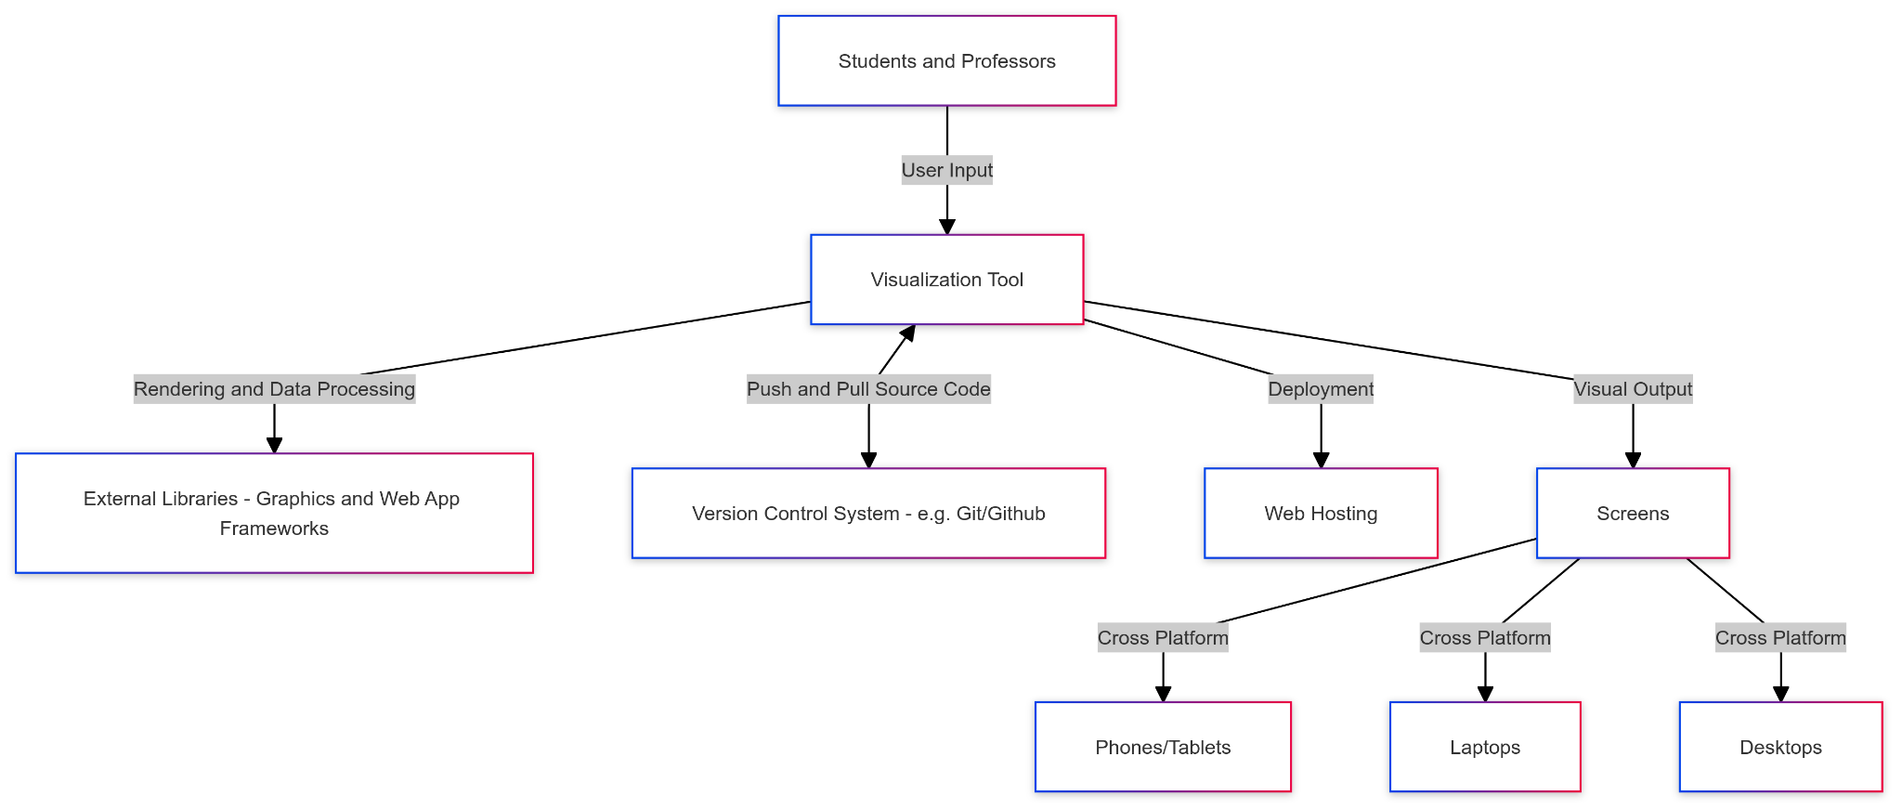

# 

# Requirements Specification

| **ID** | **Project Requirement** | **Description** |
| --- | --- | --- |
| 1 | 2D Application | **Constraint:** This is the visualization target to reduce complexity. |
| 2 | Accessibility (Color Blindness, Dyslexia) | **Objective:** The application can be considered more successful if we support a larger variety of disabilities, but minimally the interface will support accessibility options for students with color blindness, or dyslexia. |
| 3 | The polarity, magnitude, velocity, number of point charges may be adjusted | **Functional Requirement:** Users must be able to make adjustments for:  Polarity: - or +  Direction: Users can adjust direction along $x, y,$ or $z$ (into the screen, out of the screen) axis  Magnitude of each point charge: $Q_{min}≤Q≤Q_{max}$ |
| 4 | The direction and magnitude of the magnetic field may be adjusted | **Functional Requirement:** Users must be able to make adjustments for:  Magnitude of magnetic field: $B_{min}≤B≤B_{max}$ |
| 5 | Measuring magnitude and direction of force exerted onto a point charge due to the magnetic field | **Functional Requirement:** Users must be able to determine and visualize the magnitude and direction of the magnetic force, as a result of their chosen parameters |
| 6 | Capable of operating on all devices (laptop, phone, PC, tablet, server, projector etc) | **Objective:** The larger variety of devices and browsers supported the better, but at bare minimum the interface should be adaptable to a variety of common personal computer screen sizes and aspect ratios (16:9, 16:10, vertical screen counterparts for mobile devices/tablets) |

# 

# 

# Project Milestones

The milestones of the project correspond to phases in the implementation and deployment process. These milestones help us to structure the project, ensuring a smooth progression from technical setup to final deployment. Each milestone ensures we work in a modular, bottom-up fashion, working to create reusable components which will be used in the subsequent milestones

**M0: Tech Stack Setup (October 2024)**In this phase we select and set up powerful, well-documented tools (web frameworks, graphics, APIs). We will gather and index documentation to smooth the development process.

**M1: Point Charge Visualization (November 2024)**Create a basic visualization of a movable point charge, allowing users to adjust position, magnitude, and polarity. Acts as proof of concept.

**M2: Basic Electric Field Visualization (December 2025)**Create a basic visualization of a movable point charge, allowing users to adjust position, magnitude, and polarity. Acts as proof of concept.

**M3: Basic Magnetic Field Visualization (January 2025)**This milestone will focus on building the magnetic field visualization consisting of a point charge, moving with velocity within a static magnetic field, and drawing the correct resultant magnetic force vector, displaying all relevant quantities and units

**M4: Modeling Complex Interactions (February 2025)**This phase will build on the basic visualizations by incorporating more complex interactions between multiple sources of electric fields, and adding animations to the magnetic field effect visualization

**M5: UX Design/UI Overhaul (February 2025)**Comprehensive user interface overhaul. This milestone will refine the visual layout, with focus placed on making the application intuitive and accessible.

**M6: Integration & Testing (March 2025)**This milestone brings all components together and conducts extensive integration testing

**M7: Bug Bash (March 2025)**A dedicated phase for debugging and refining the final product. During this period, we will address any issues found during integration and testing, ensuring a smooth user experience.

# **M8: Deployment (Pre- Design Fair 2025)** The final phase will involve deploying the finished project. The deployment milestone ensures that the tool is ready for use and can be accessed by the target audience.

# Feasibility assessment

The completion of this project requires competencies in several key areas. Web development skills are the most important for this project because this app will be web based. The user interface and backend (what happens “behind the scenes”) will have to be well implemented to ensure fast performance, smooth graphics, and an intuitive user experience. Knowledge and skill will be required in the areas of electric and magnetic fields, software libraries such as PixiJS, website deployment and hosting as well as graphics rendering and animation.

Our team has already acquired a foundational understanding of web development during our respective internships. Additionally, two team members are taking a software engineering course that covers industry best practices for developing web applications. All team members have completed courses in electricity and magnetism where they have learned the fundamentals of electric and magnetic fields well. We are currently lacking expertise in the domains of deployment and graphics rendering. To address the deployment challenge, we plan on reading online tutorials, watching instructional videos and investigating popular hosting resources. For graphical rendering, we plan on reading online documentation, examining the implementation of similar projects and watching online tutorials.

The primary risks for this project involve accurately representing movement of charge. This includes calculating the travel path and animating the motion on-screen. We will address this concern by writing software tests verifying physics simulations and animations. Another significant challenge is possible maintenance required for the project after our graduation as well as its ensuing costs. We plan on mitigating this by selecting a low-cost, reliable hosting platform and thoroughly documenting the application for future use. We also think that portability could be a risk. We would need to prevent distortion or loss of visuals when translating animations from a big computer screen to a smaller one (like a phone). Lastly, ensuring high performance will be critical to the success of our application. Our application requires many different objects to be rendered on the screen every millisecond. With so much going on at once, it will require efficient algorithms and data structures in order to ensure smooth animations for the user.

# References

[1] "Charges and Fields," PhET Interactive Simulations, University of Colorado Boulder. [Online]. Available:<https://phet.colorado.edu/sims/html/charges-and-fields/latest/charges-and-fields_all.html>. [Accessed: 17-Sep-2024].

[2] "PixiJS - The HTML5 Creation Engine," PixiJS. [Online]. Available:<https://pixijs.com/>. [Accessed: 17-Sep-2024].

# Appendix

Survey Question 1

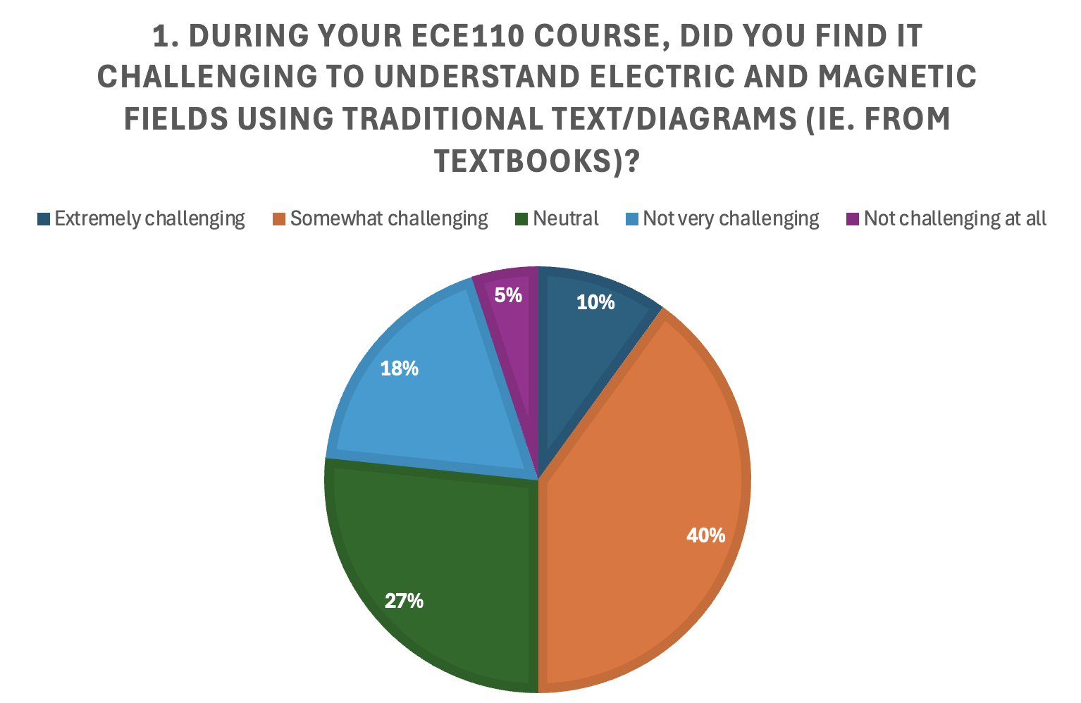

Survey Question 2

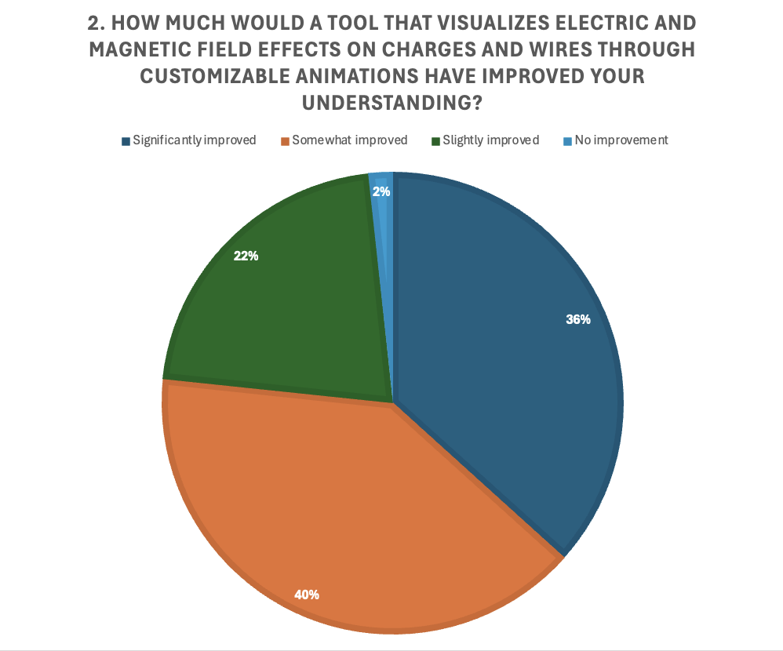

Survey Question 3

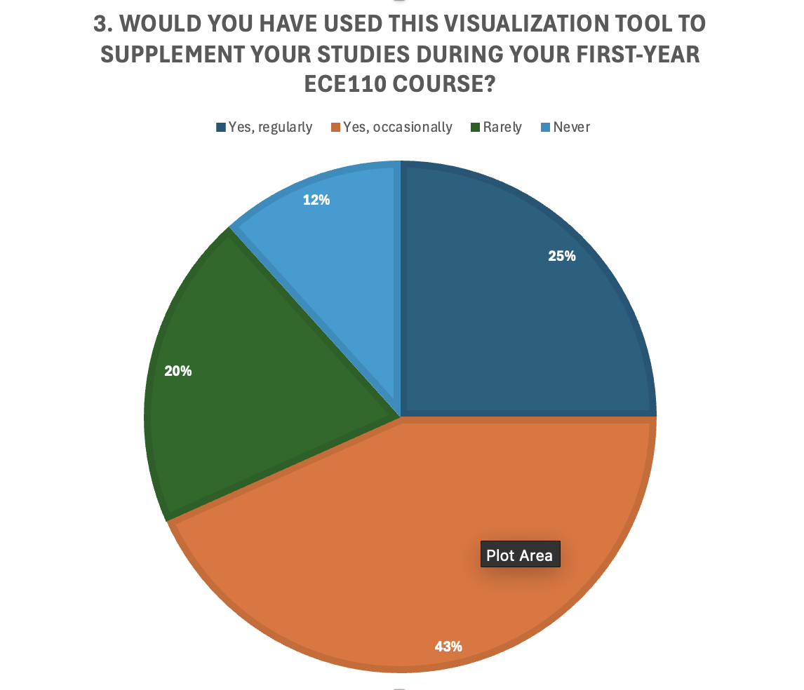

Survey Question 4

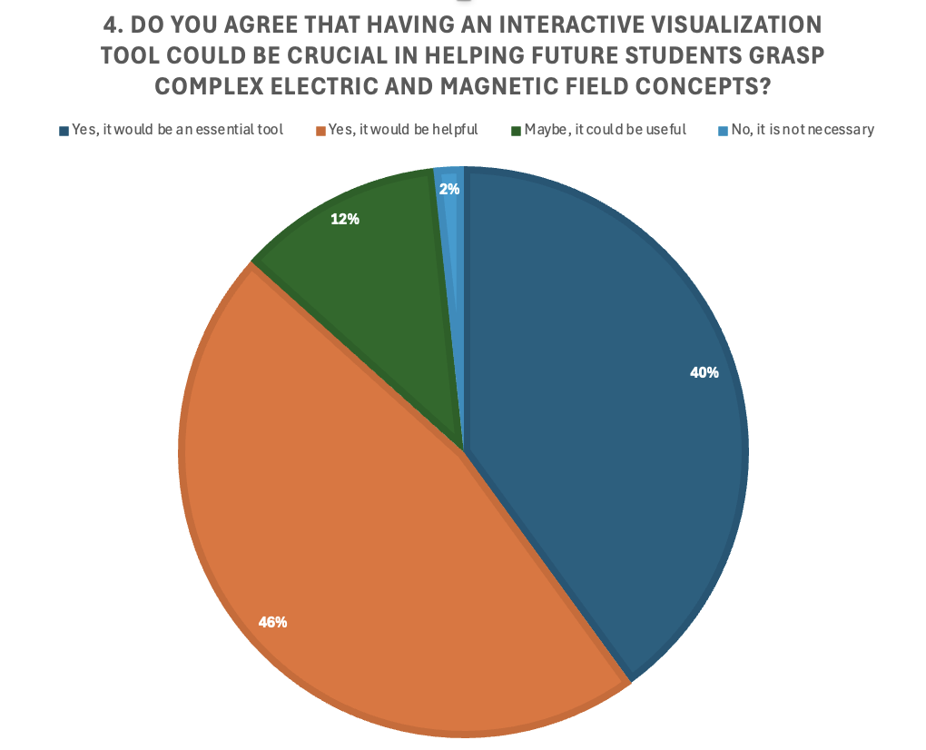

Survey Question 5

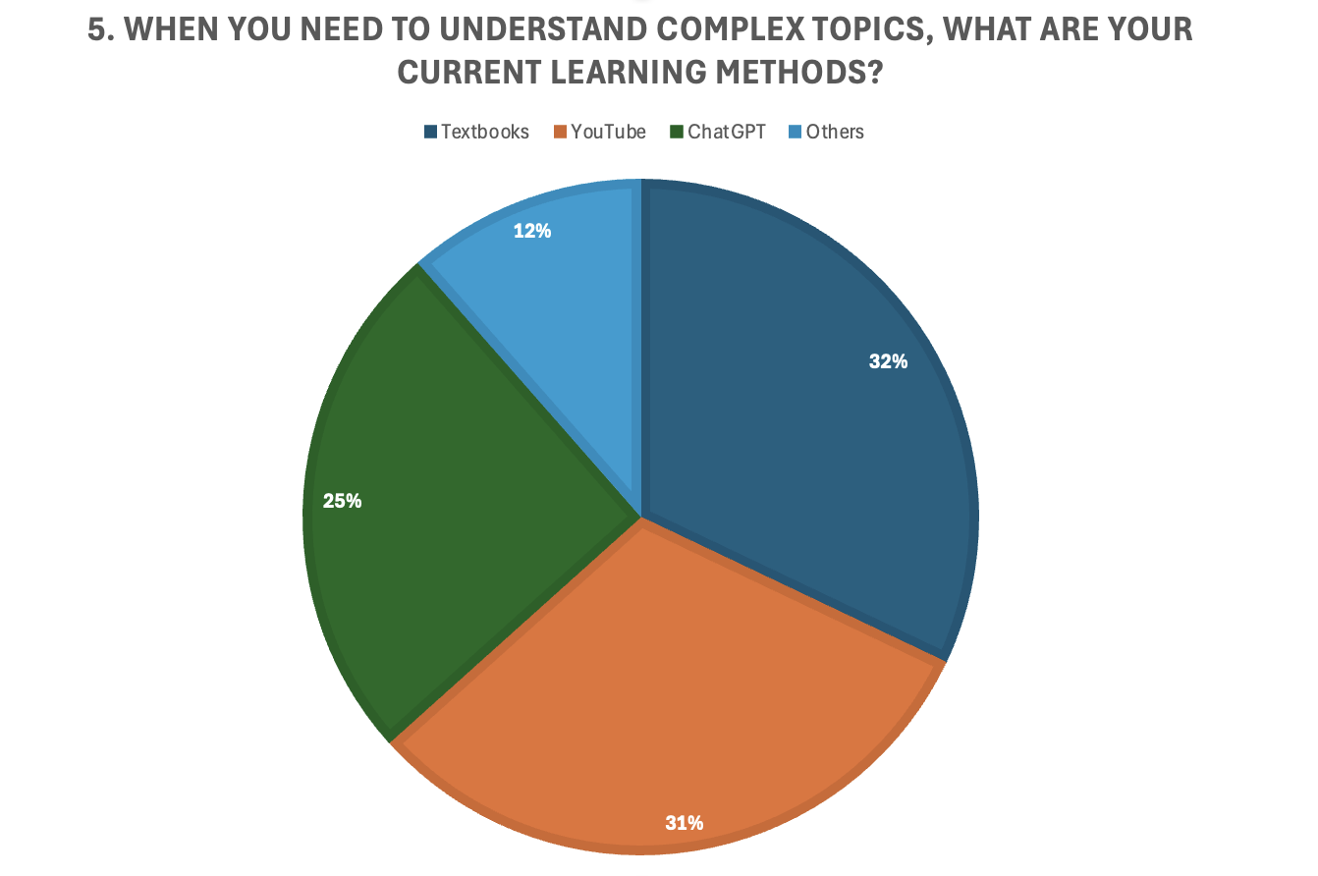

Survey Question 6

